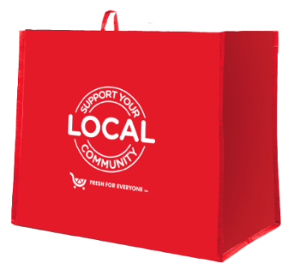
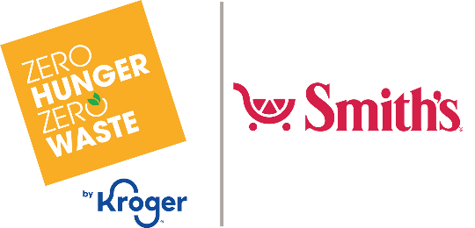

Announcement Email

SUBJECT LINE: We’ve been selected to partner with the Smith’s Fight Hunger bag program!
PREVIEW TEXT: For all of [month 1 and month 2], every Fight Hunger bag purchased at our selected Smith’s location(s) will send us a $1 donation.

Dear [Staff/Board/Volunteers/Supporters],

We are excited to share that Smith’s selected [organization] to benefit from the Fight Hunger bag program throughout [month 1 and month 2]. Designed in alignment with Smith’s Zero Hunger | Zero Waste initiative, the Fight Hunger bag program makes it easy for shoppers to support local hunger relief organizations by simply purchasing a reusable Fight Hunger bag!

For the months of [month 1 and month 2], every time a $2.50 reusable Fight Hunger bag is purchased at the Smith’s located at [address of selected store(s)], $1 will be donated to [name of organization]. We are thrilled to have this opportunity to broaden awareness of our mission and raise donations for our cause.

Let’s get started! Share the news with your friends and family. Call, send emails, and post on social media. The more people who purchase the Fight Hunger bag in [month 1 and month 2], the greater the donation we will receive from Smith’s!

Best,
[Signature]

